Owen Huang 9/26/19 CSE 332

Lab 2

So, my dataset for this lab has to do with the suicide dataset found on Kaggle. So, it is a compiled dataset pulled from four other datasets, so the data is kind of random/mixed.

So, let me explain what data I used, how I got the data, and what type of bar graphs I am making with them. So, there are a total of 12 attributes, but I believe that some are the same or can give the same information. Additionally, some of the data having nothing in them so we won’t be using those. So, the four attributes are **country**, **year**, **sex**, and **age group** which I’ll will be making bar graphs out of.

Data Example:

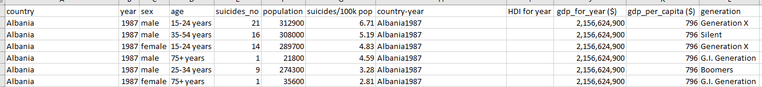

So originally, I had one big csv file which I divided into four different csv of the attributes discussed above. I originally had around 35,000 data from 1985 to 2016. There was too much data, so I only used the data that is from 2000 to 2010. However, not all countries have suicide data from 2000 to 2010(exp. Some had 2000-2005 only). So, I just rode some code to give me only the countries that contain all data between year 2000-2010. This in total decreased the data from 35,000 to around 8500. Afterwards I just created separate csv files for the attribute I wanted and summing up the suicides.

Example of my python code to shorten data.

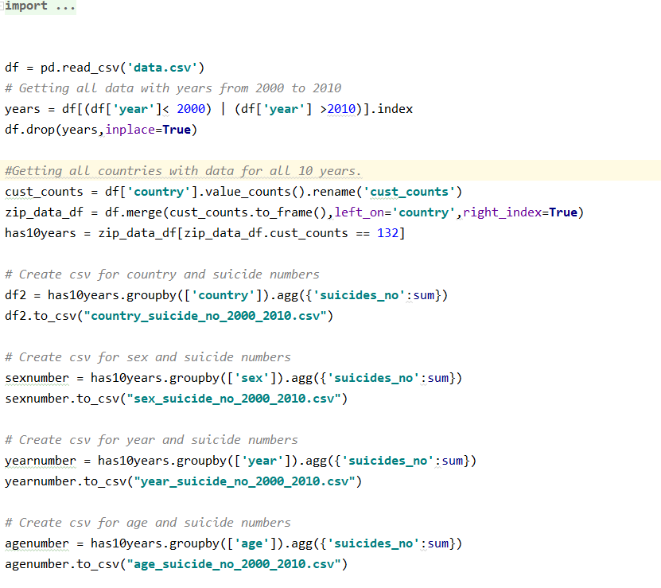

Example of csv files:

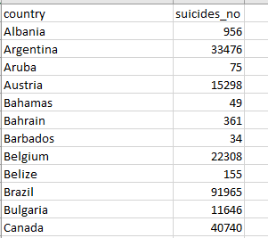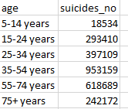

So now onto the graphs: A example of what you will see

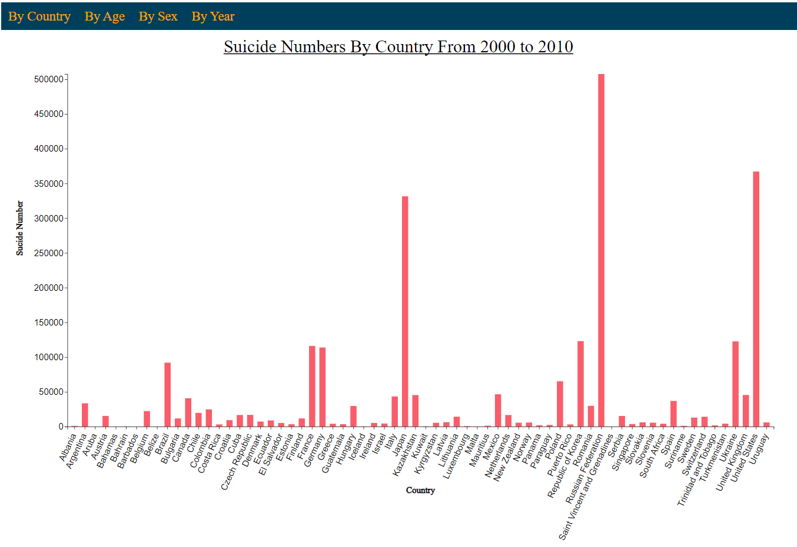

So, for starters you can see that we have a navigation bar on top which will be used to change between the different attributes that we want to show. So, the y-axis contains the suicide numbers and the x-axis contains the variable that we are trying to show which would be the country, sex, year, and age. As you can see the x-variable is slanted since if I put all those variables horizontally, they would overlap.

So, some functionality it has would be how if you hover over a bar it would highlight it and additionally show the number of suicides that bar represents. You can see below

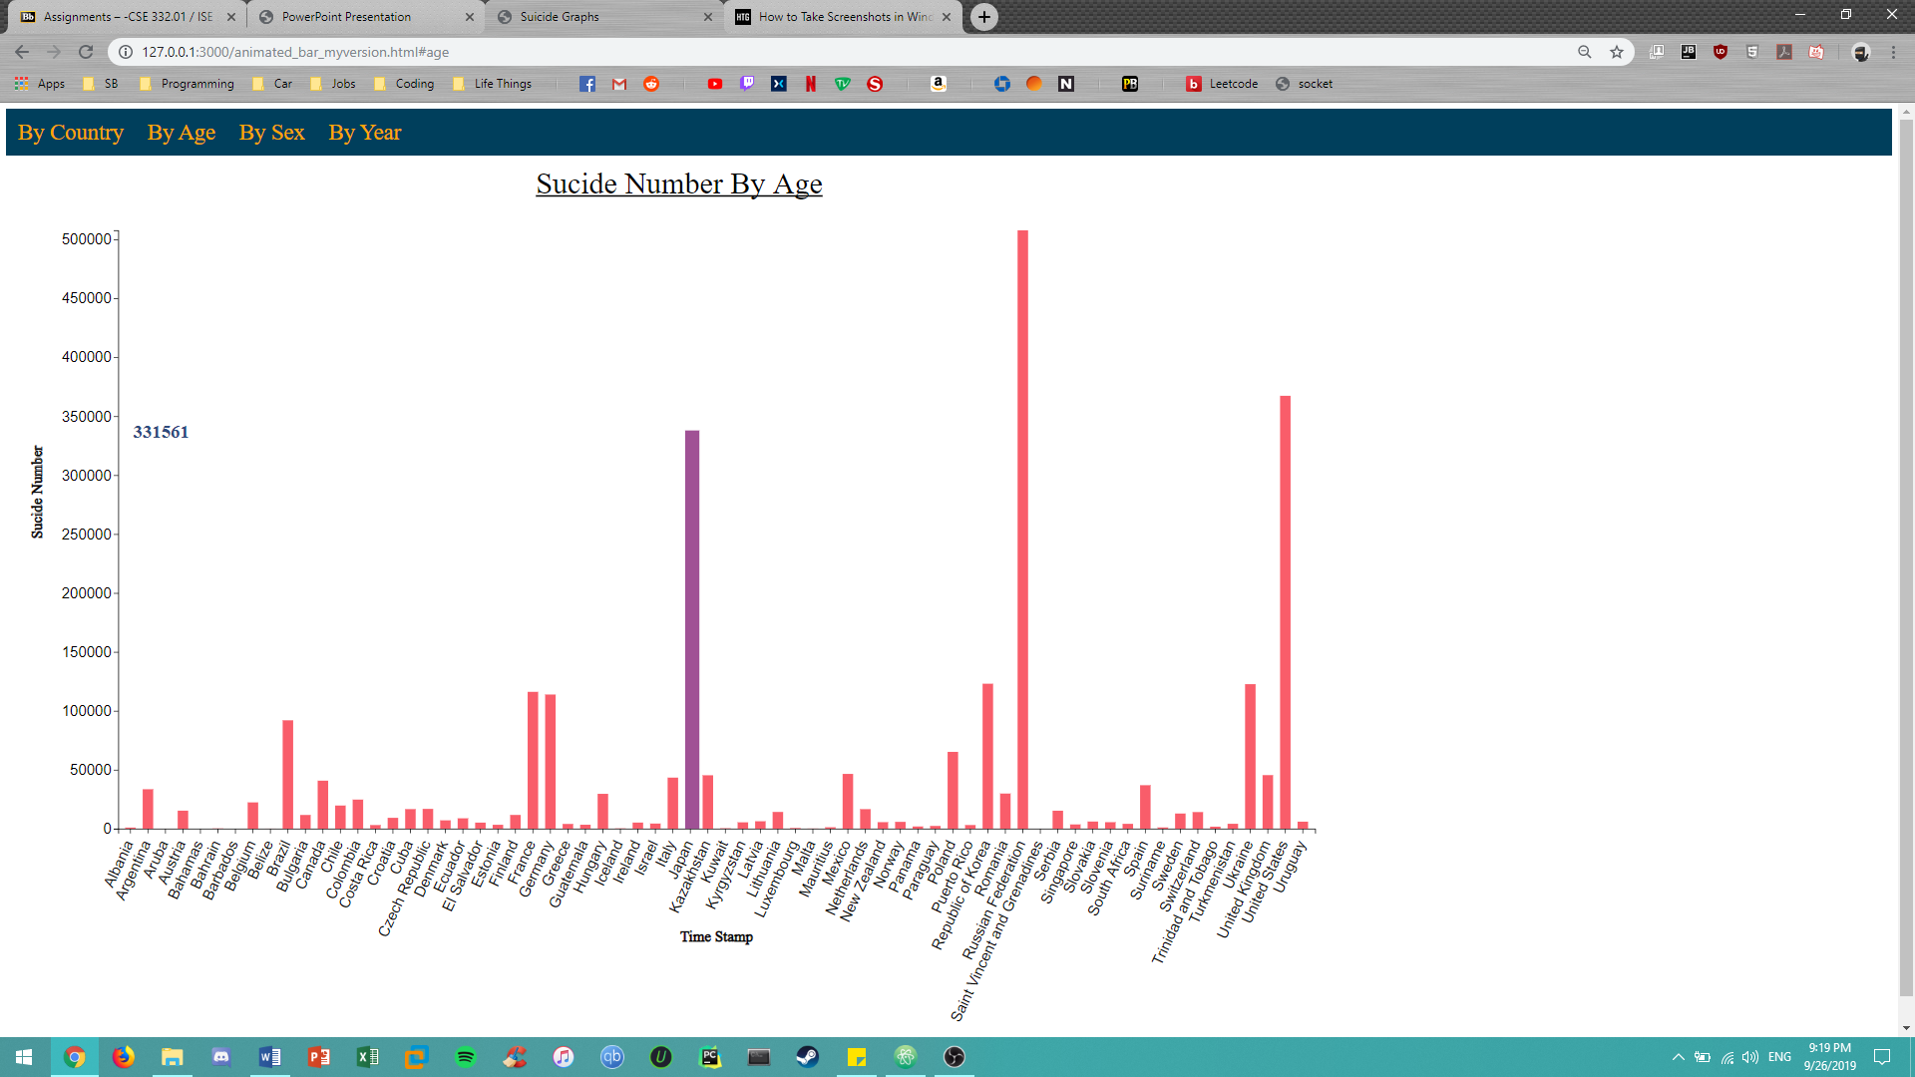

As you change to different graphs either by clicking on screen or through drop down menu, you will notice a transition where everything changes from the y-axis to the bars. Also, as you change graphs you can see them come down which is another transition. This is done by the change function in my code. The code kind of long but here what the function looks like

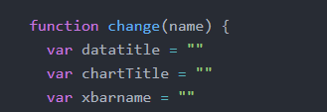

That’s basically it. I discuss in my video on what the graphs shows. Go check it out.